**Name: Deepika Rani Gokavarapu**

**700#: 700740599**

**Programming Assignment 1**

GitHub Link: <https://github.com/GDeepikarani59/MachineLearning_Assignment1>

Video Link: <https://drive.google.com/file/d/15ajNWyxPjz1axvE-LH2AWMFMrpCLXmIi/view?usp=drive_link>

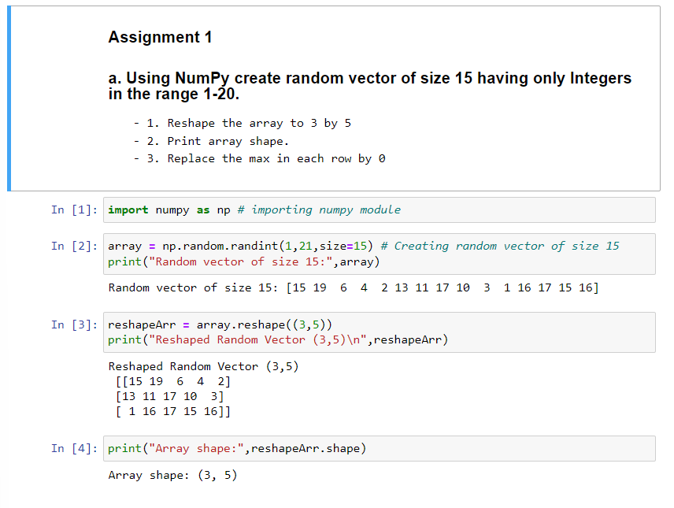

With the help of NumPy, the following code generates an array of 15 numbers, resizes it into a 3x5 array, then substitutes the maximum value for each row with 0. It creates a vector using random.randint(), reshapes it using reshape(), and then uses print() to show the shape of the array. Using argmax() and NumPy's indexing syntax, the maximum value in each row is changed to 0 for each row. After that, print() is used to display the output array.

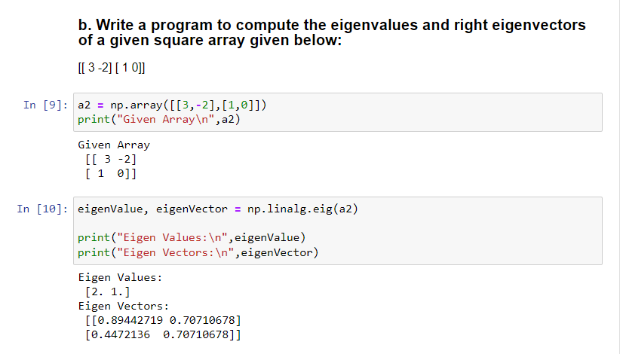

The eigenvalues and right eigenvectors of a given 2x2 square array are calculated using NumPy in this code. The right eigenvectors and eigenvalues are calculated using np.linalg.eig(), and the array is constructed using np.array(). Print() is used to show the resulting eigenvalues and eigenvectors.

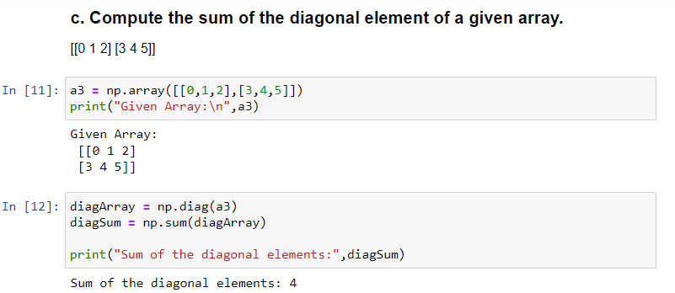

This program utilizes NumPy to calculate a 2x3 array's diagonal elements' sum. The diagonal element total is calculated using np.diag() and then summed using np.sum() after the array has been defined using np.array(). Print() is used to display the total as a result.

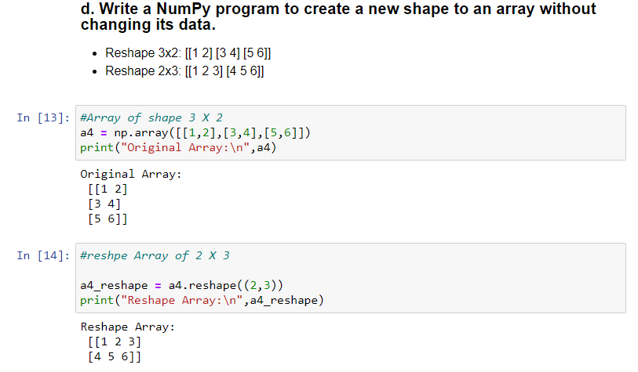

In this program, a 2-dimensional array is transformed into a 2x3 array, using NumPy. The reshape() function is used to reshape the array to the appropriate shapes once the original array is defined using np.array(). The print() function is then used to display the generated arrays.

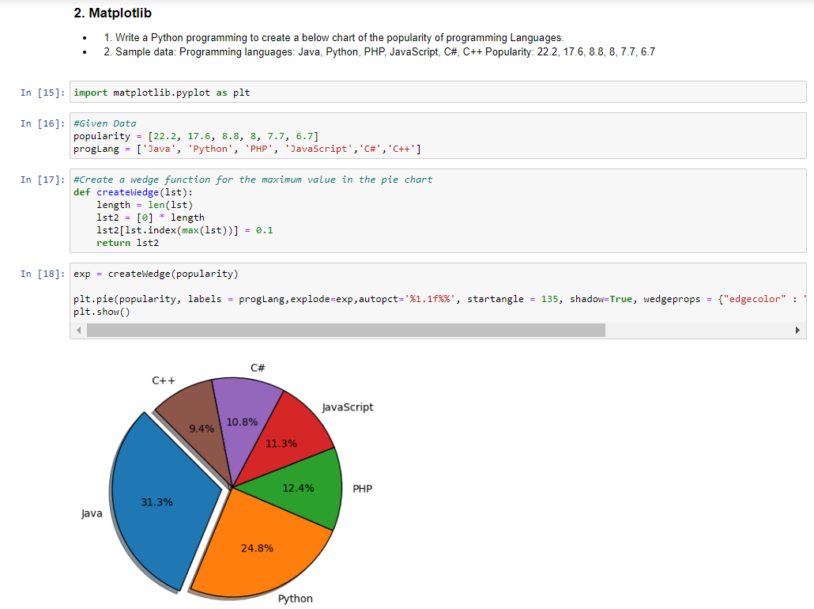

This Python code snippet creates a pie chart depicting the usage of different programming languages by using the matplotlib.pyplot package. The data to plot, the colors to use for each slice of the chart, and the amount to "explode" each slice are all specified in the code. The chart is then made using the pie function, with many options for labeling, formatting, and appearance. Finally, the chart is displayed using the show() function, and the aspect ratio is configured to be equal.